Aim : Create 2 Virtual Networks : Vnet_ 1 And Vnet_2

Creating Two subnets in each Vnet.

Create Virtual Machine of Vnet-1 and Vnet -2

Assign Public IP to both VM In Vnet-1 and Vnet-2

Peer Vnet-1 and Vnet2

Create a data disk and attach to VM-1

Log on to VM and initialize the disk

LETS START

Step-1:

First You must create an Resource group it is optional as Azure provides by default a resource Group

i.e [NetworkWatcherRG](https://portal.azure.com/#@thebrocode87gmail.onmicrosoft.com/resource/subscriptions/c3db4321-fd3f-4972-a594-e114202c8382/resourceGroups/NetworkWatcherRG) .

Go to resource Group and Add a new one . You will some Configuration part.

Carefully follow the step given below in the Outputs.

a.

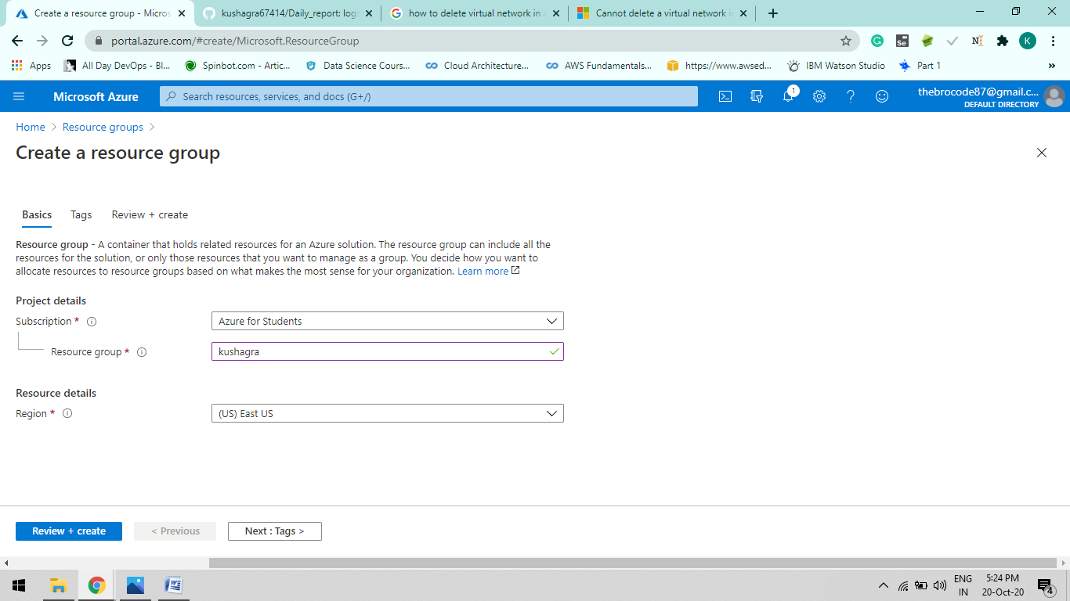

b.

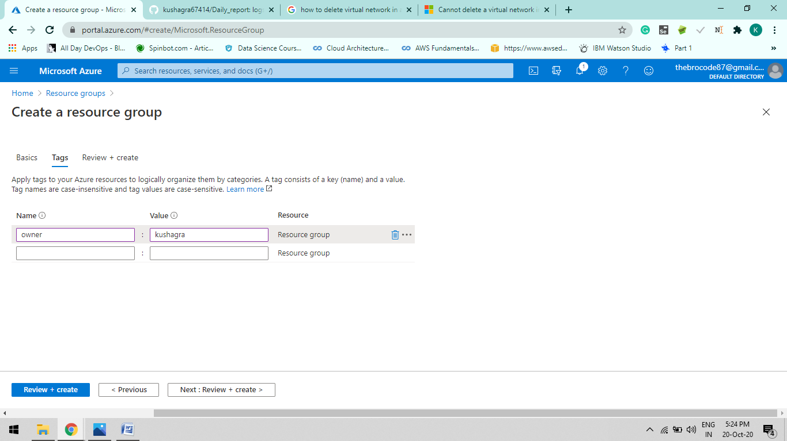

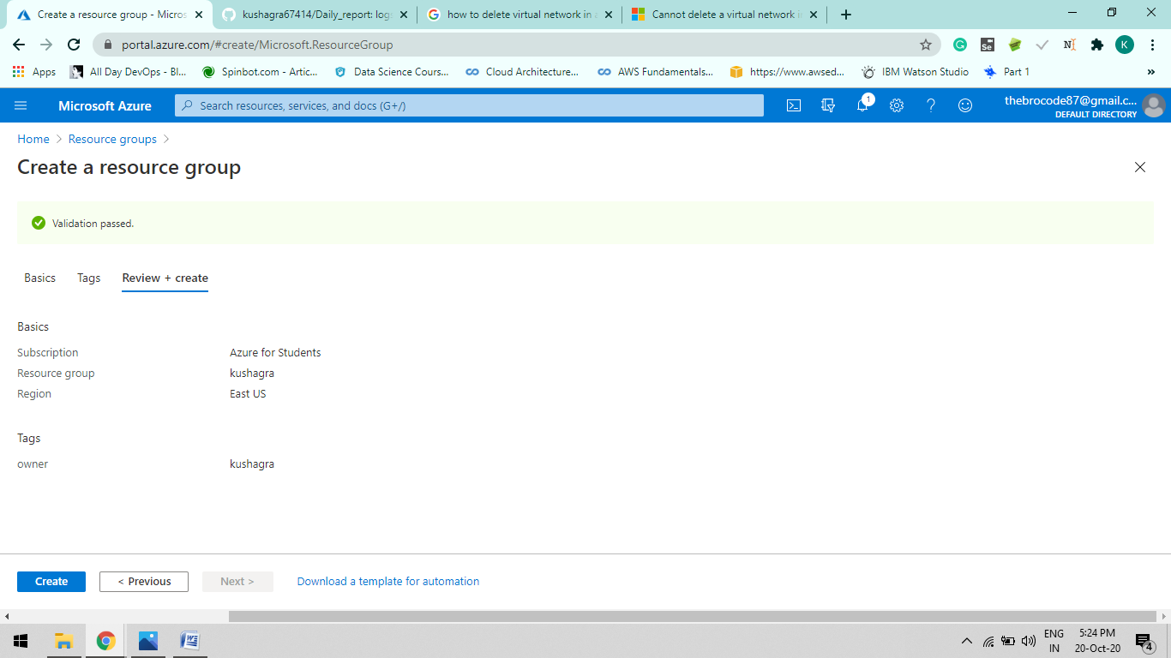

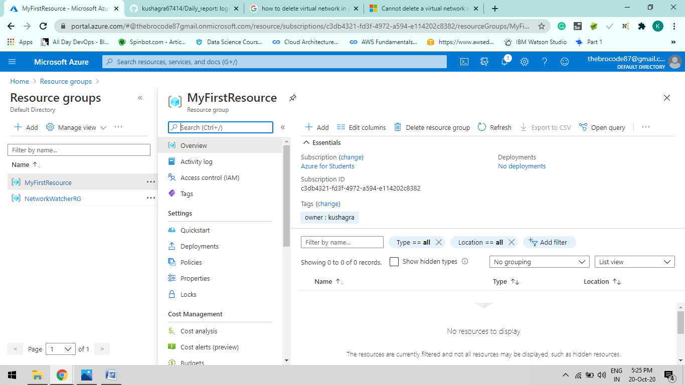

Step-2:

Go to Virtual Networks and Add TWO SUBNET’s in it. Click on Add, Now You will be redirect to the Configuration page.

Configurations like Ip address , Security , tag , Basics ,Resource Group etc etc.

Below Screenshots shows the continous way of creating the Network.[ Must carefull follow the instruction otherwise it will not pass the validate pass test].

Note : Region must be same for all the Aure services otherwise it will show the error at the time of Hosting a app.

A.

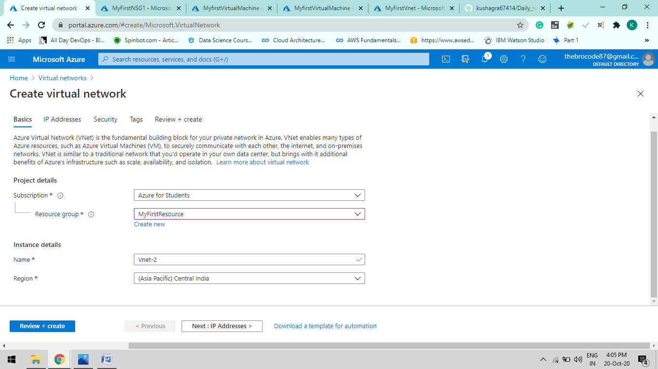

B. IP Adressing ( here we will create our own IP range ) and creating a Subnet1.1

Click on “add subnet”

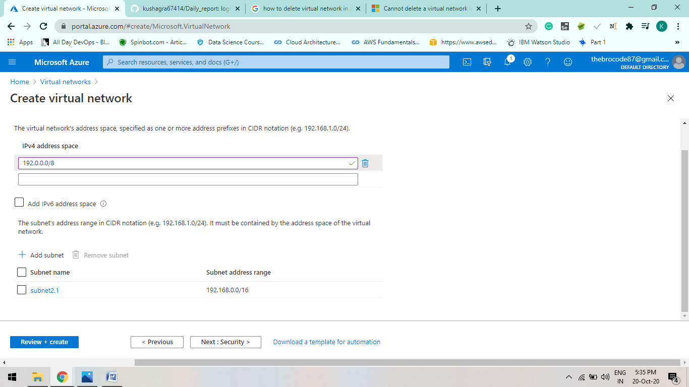

Another way of creating the subnet is: Go To Vnet-2 resource > Subnets > add subnets.

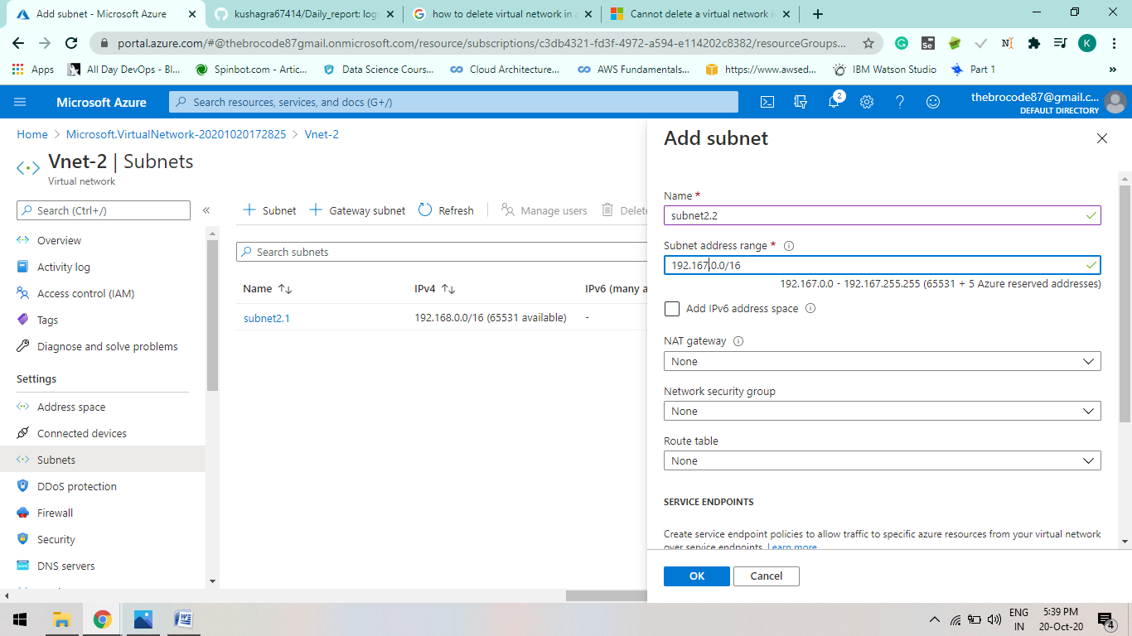

C. All same as by default in Security

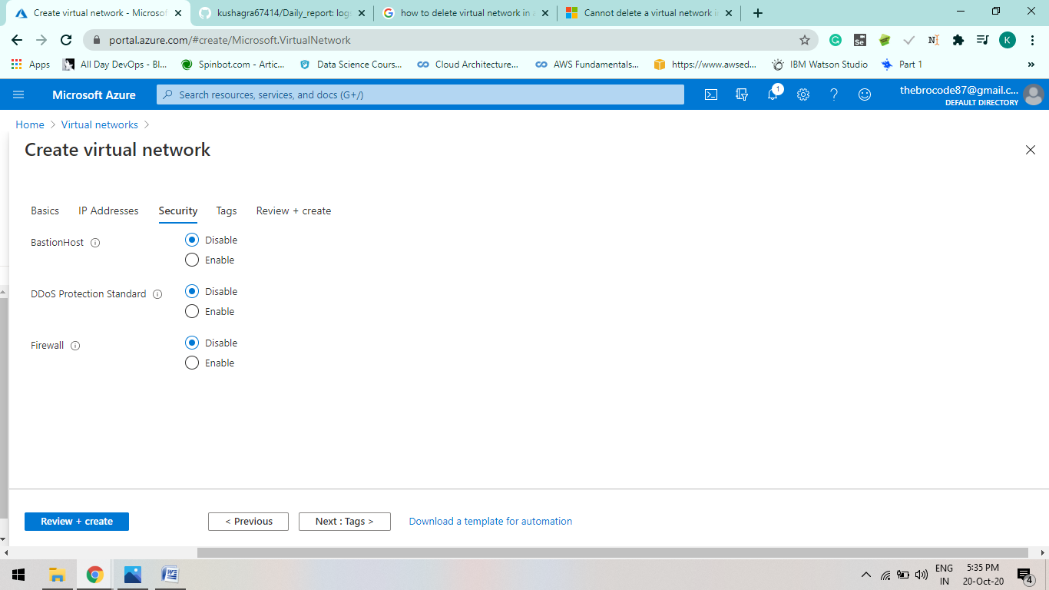

D. tags can be add

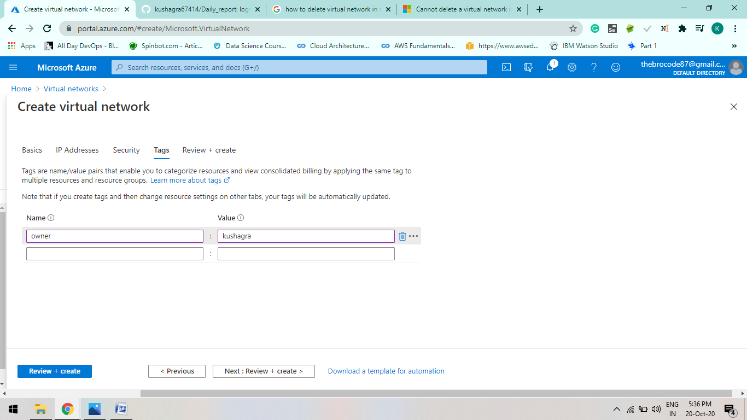

E. Review and Create: if configurations success it will show Validation passed.

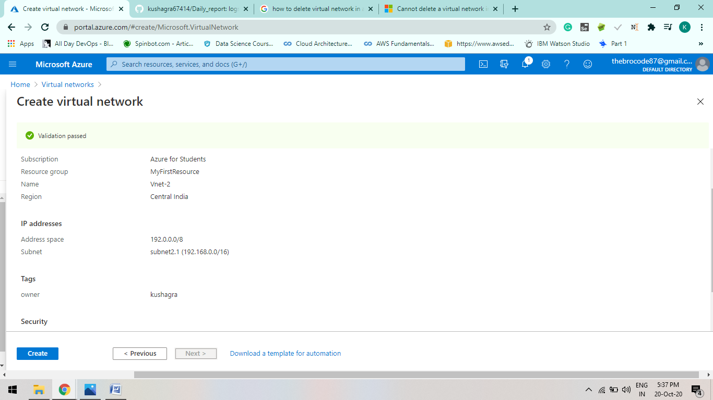

Step-3 : Create Virtual Machine of Vnet-1 and Vnet -2.

Case-1 ( For Vnet-1 )

1. Basics

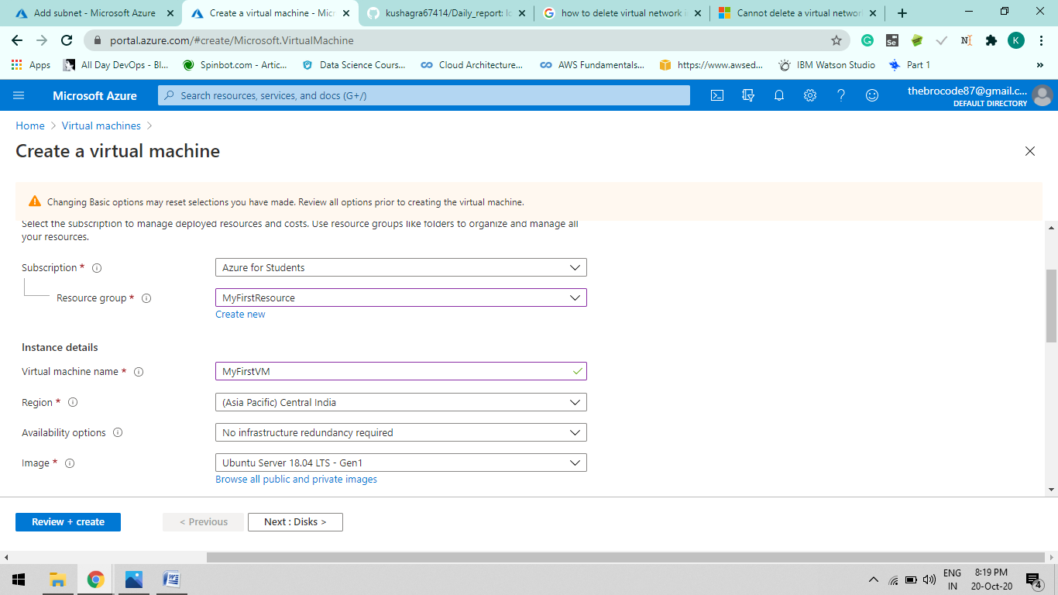

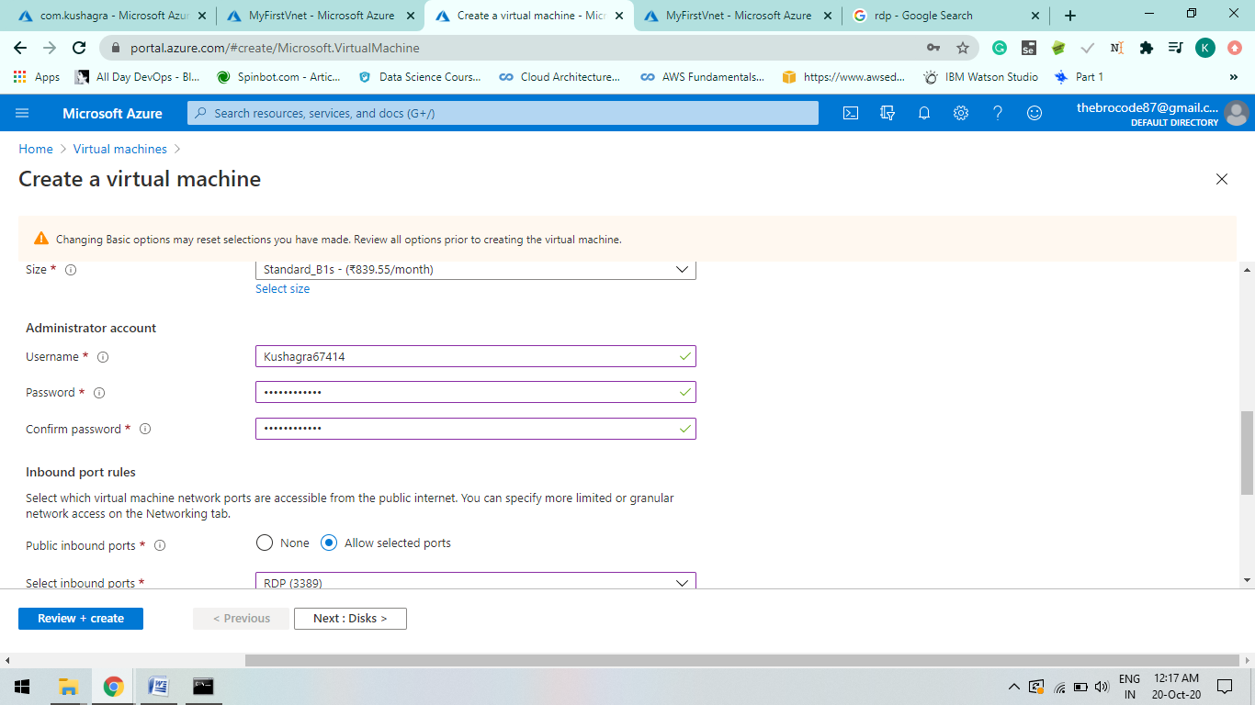

1. Disks:

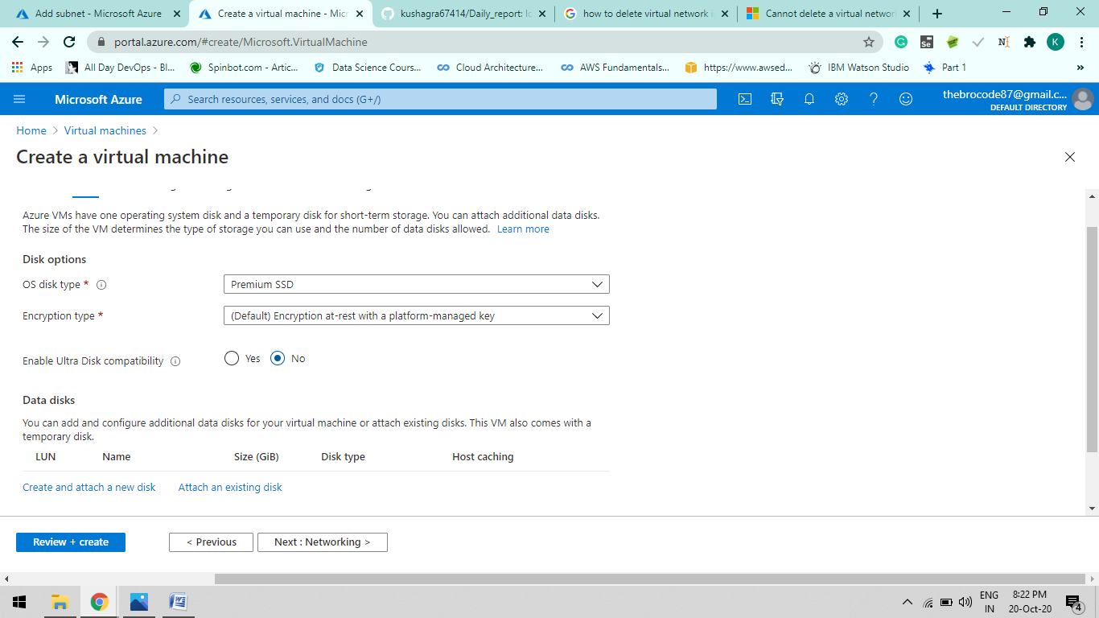

1. Networking : Vnet can choose as per the user requirements

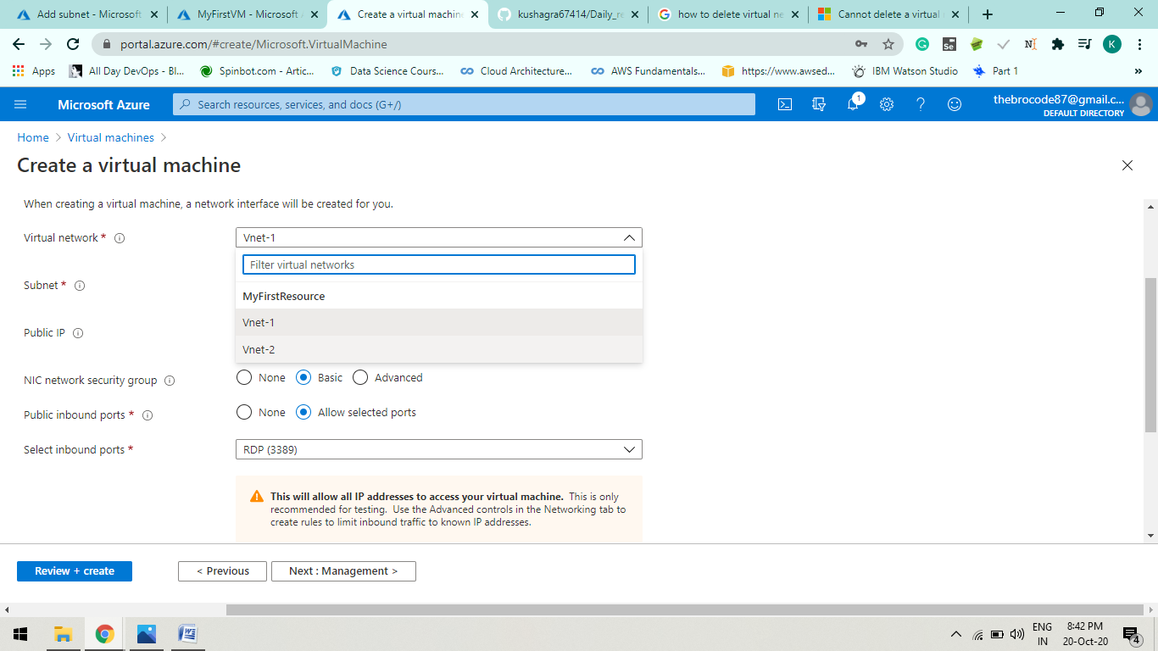

1. Management: By default value
2. Advanced: By default value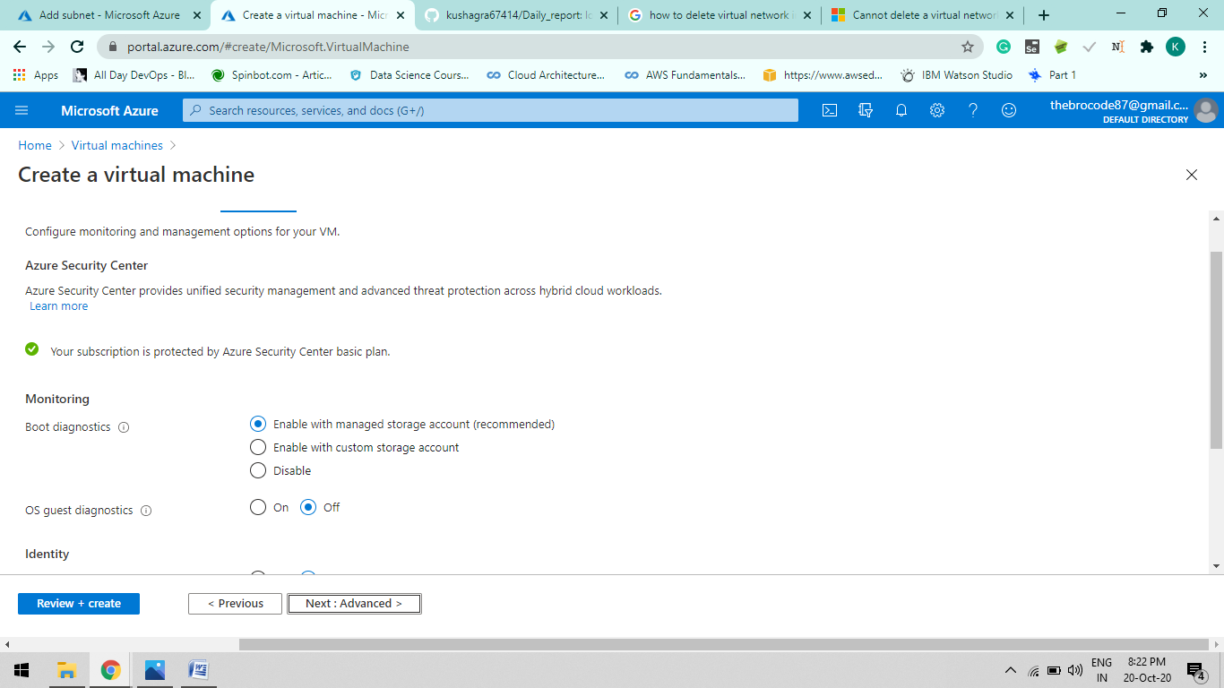

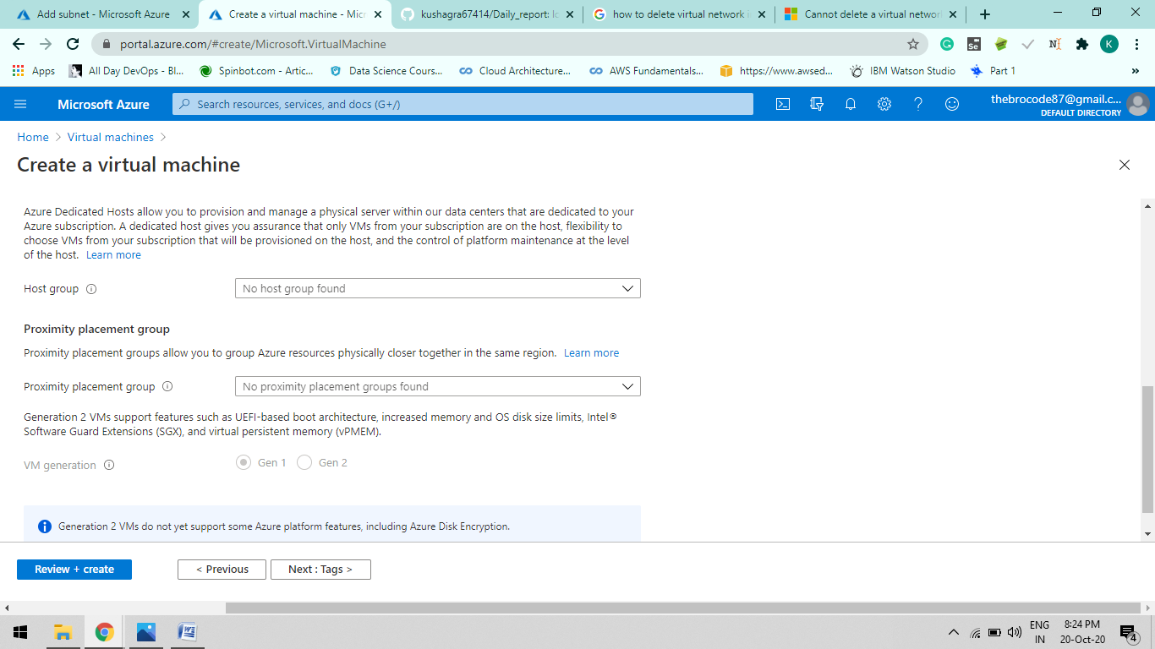

1. Tags:

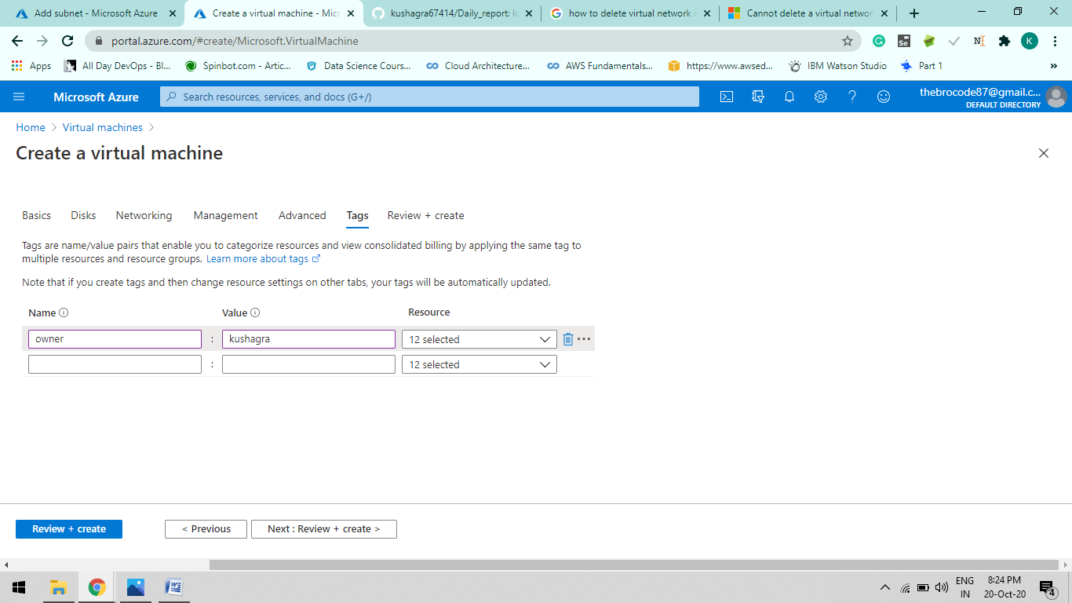

1. Review + Create: After Successful Configuration it will show Validation Passed.

And Create

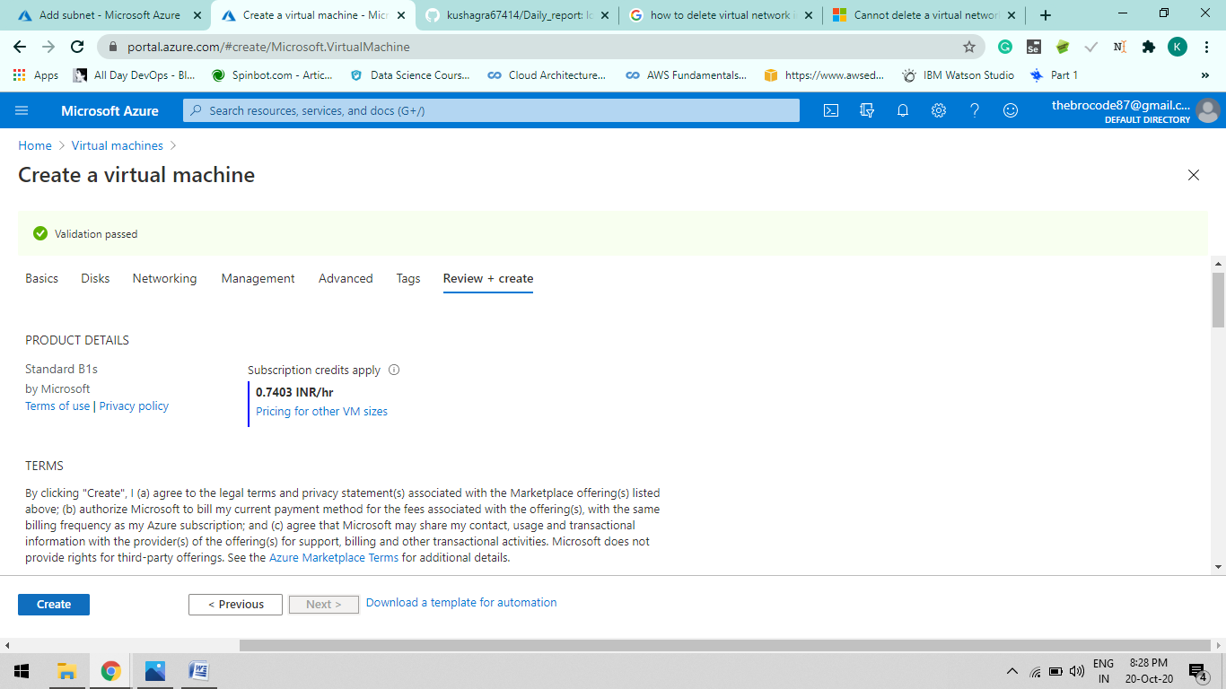

Case-2 ( For Vnet-2 )

A.

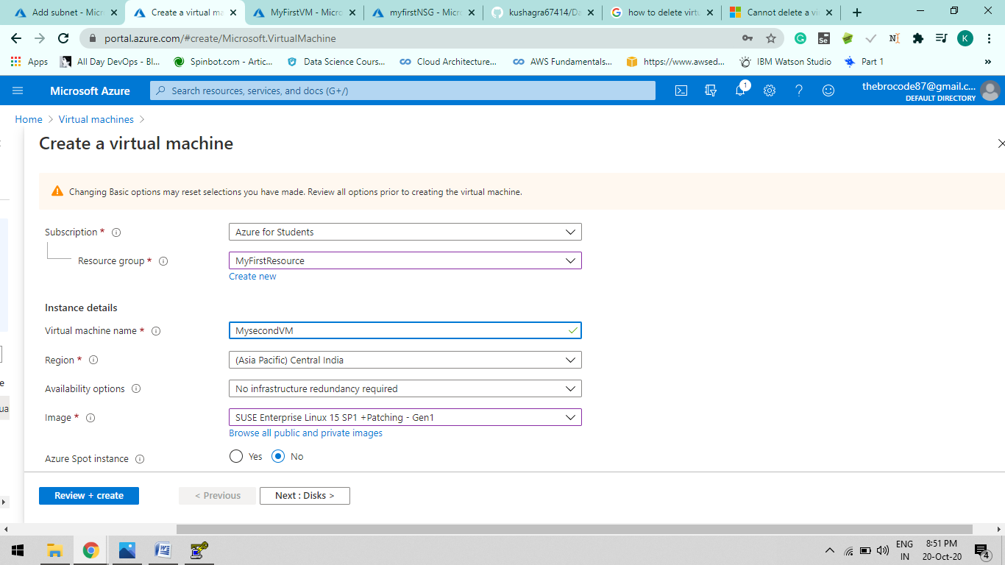

Here either you choose password or generate SSh public key. We are creating SSH public key using Puttygen, A key generator.

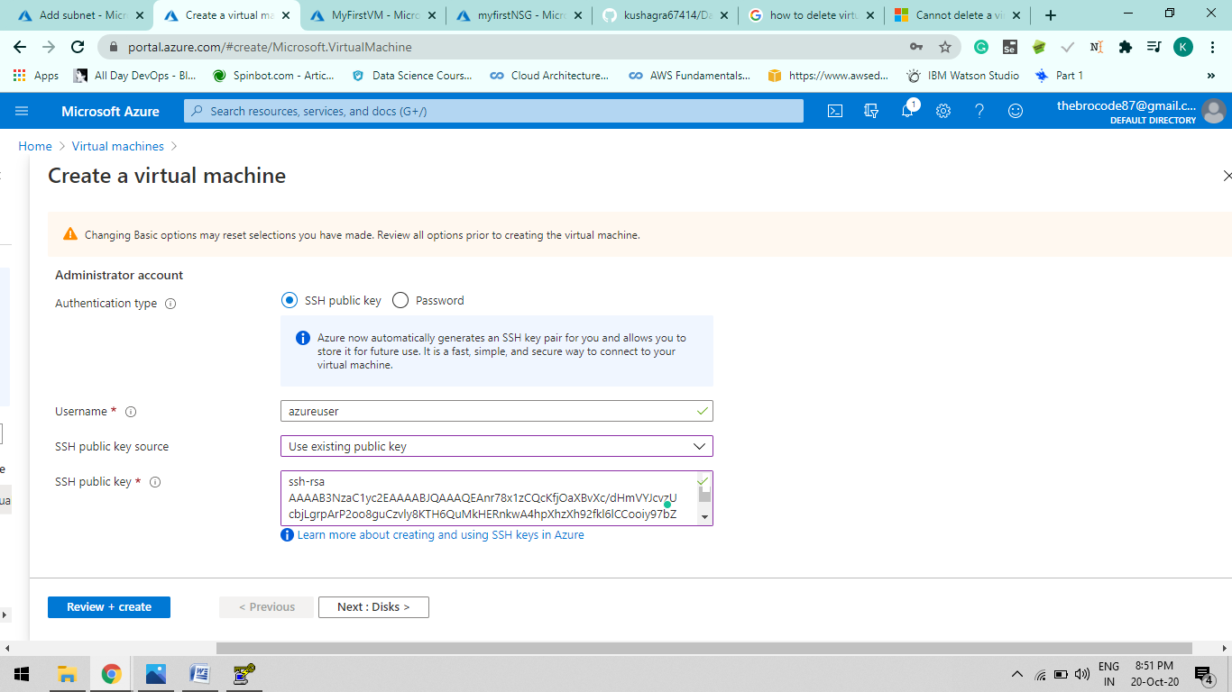

B. Disk values are default for now.

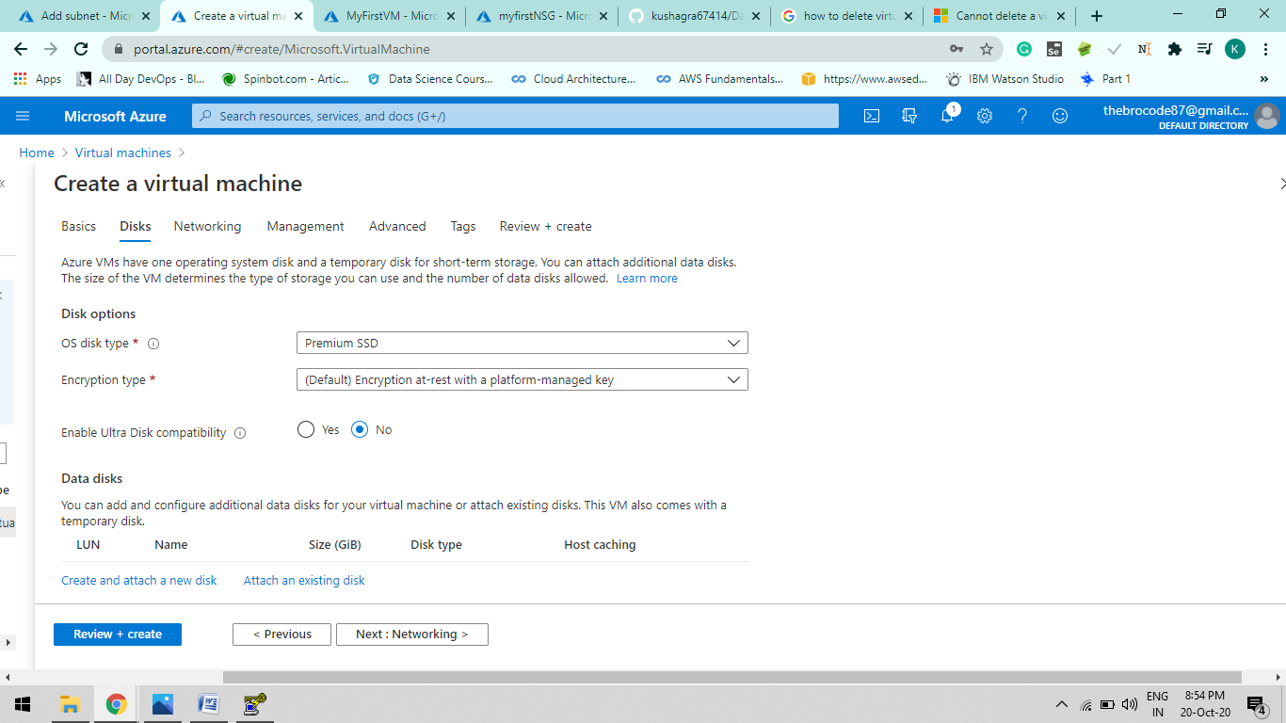

C. Networking: Can choose any Vnet which you have created i.e Vnet-1 and V-net-2

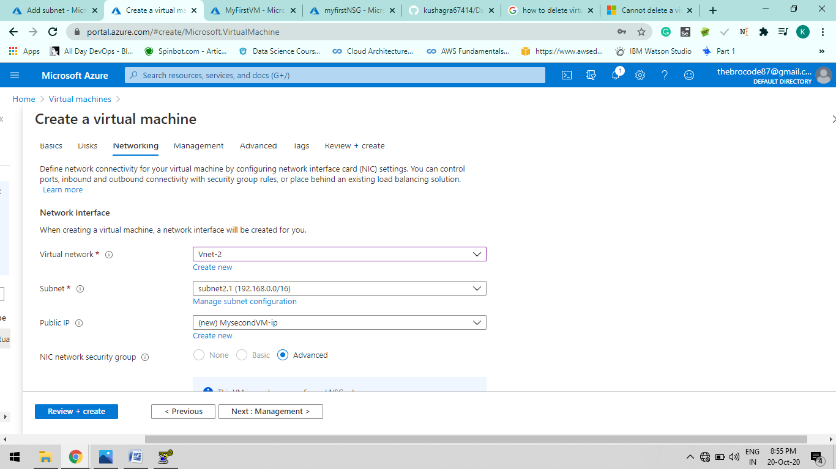

D. Management and Advance Configurations are default right now. Tags are define same as shown above . After Review + create shows the validated passed create the VM.

Step-4:

Assign Public IP to both VM In Vnet-1 and Vnet-2

Let say VM name is MyfirstVM

1. Go to created Virtual Machine > Networking > Network Interface : myfirstvm255

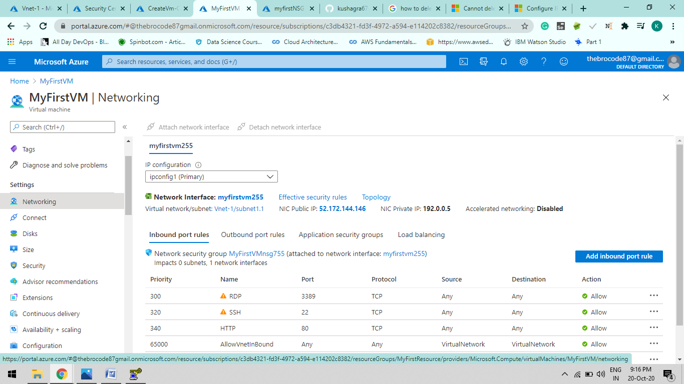

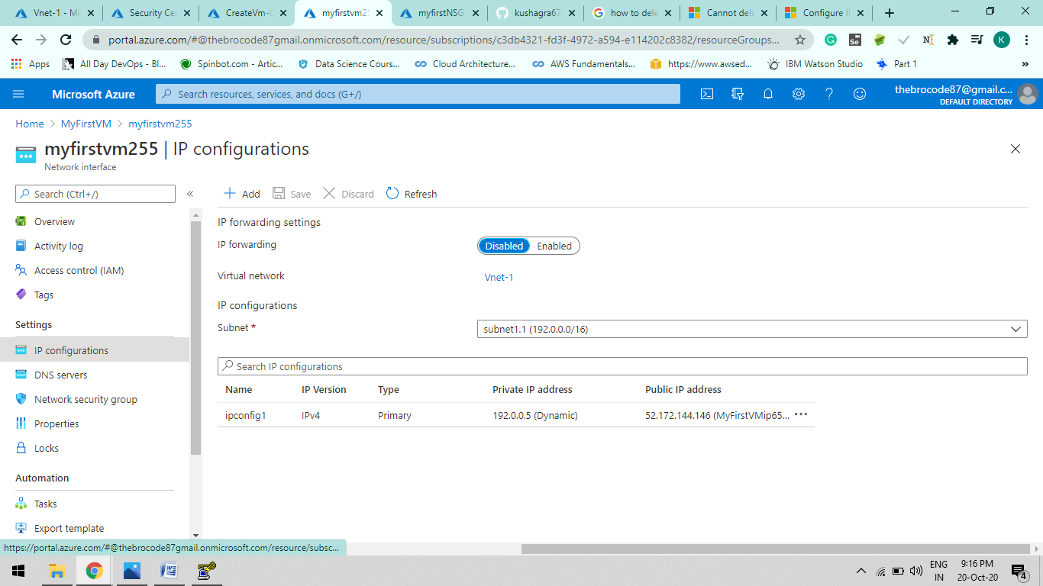

Click “ipconfig-1” and assign the IP address either Dynamic or Static.

Dynamic by default.

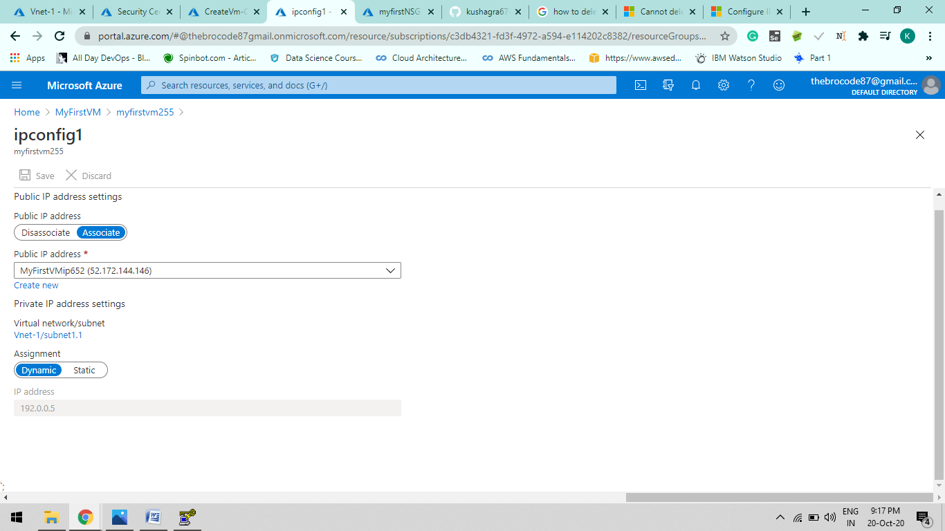

Static IP Address

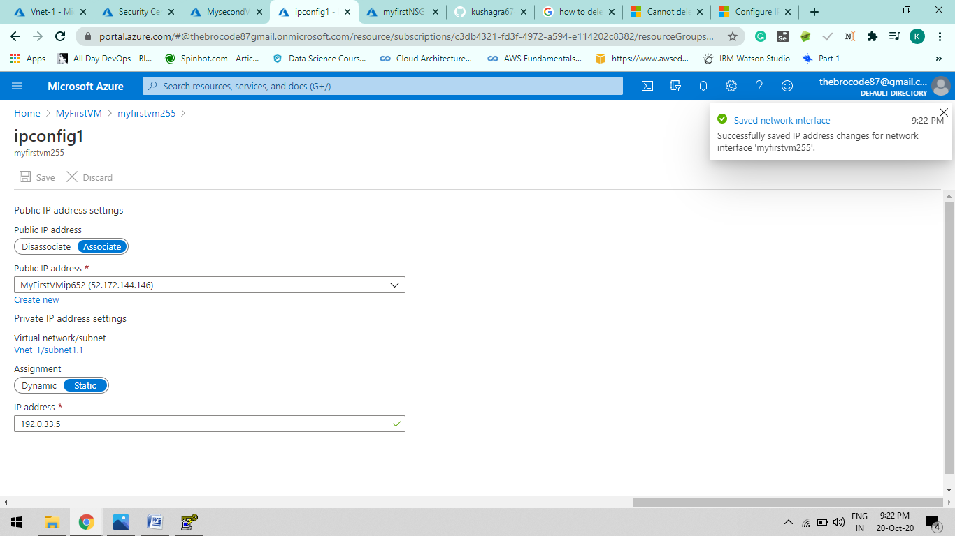

Same procedure goes with the second Virtual Machine i.e MysecondVM.

Static IP address

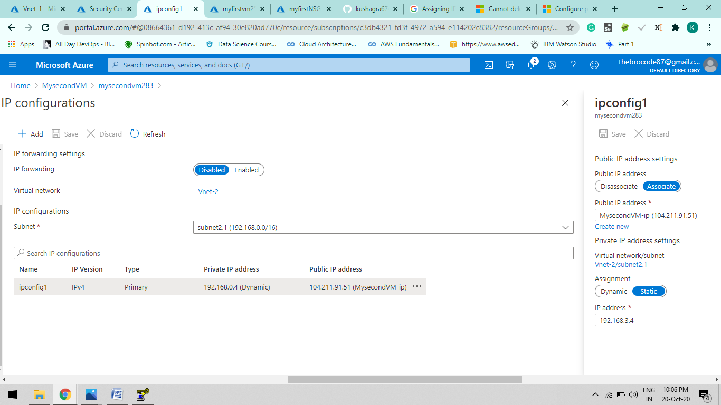

Step: 5

Peering Two Virtual Network Let say Vnet-1 and Vnet-3 ( Vnet-1 🡸 🡺Vnet-3) and Communicating between Two Virtual Machines

Go to Vnet-1 > peering > +add

A.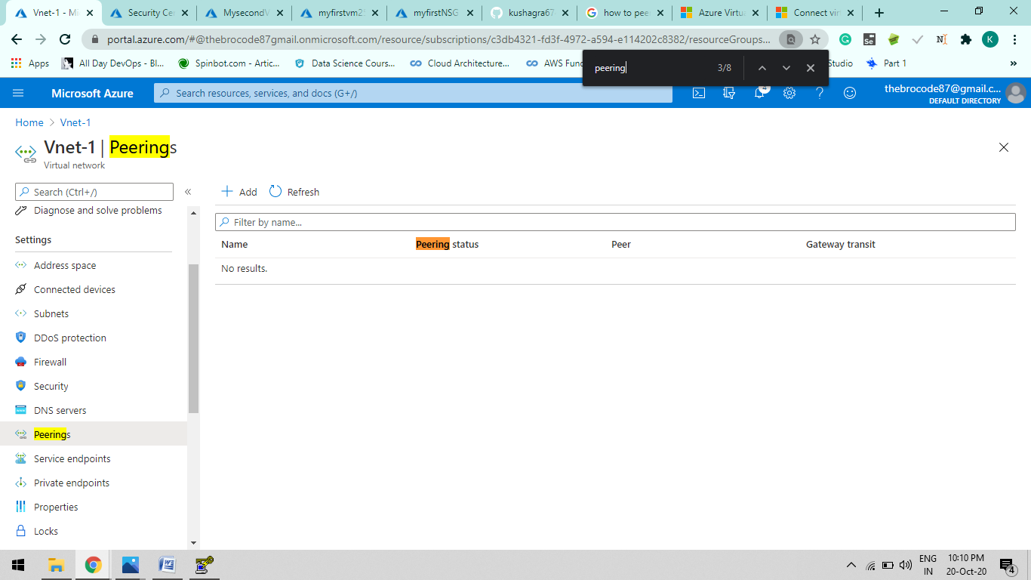

B.

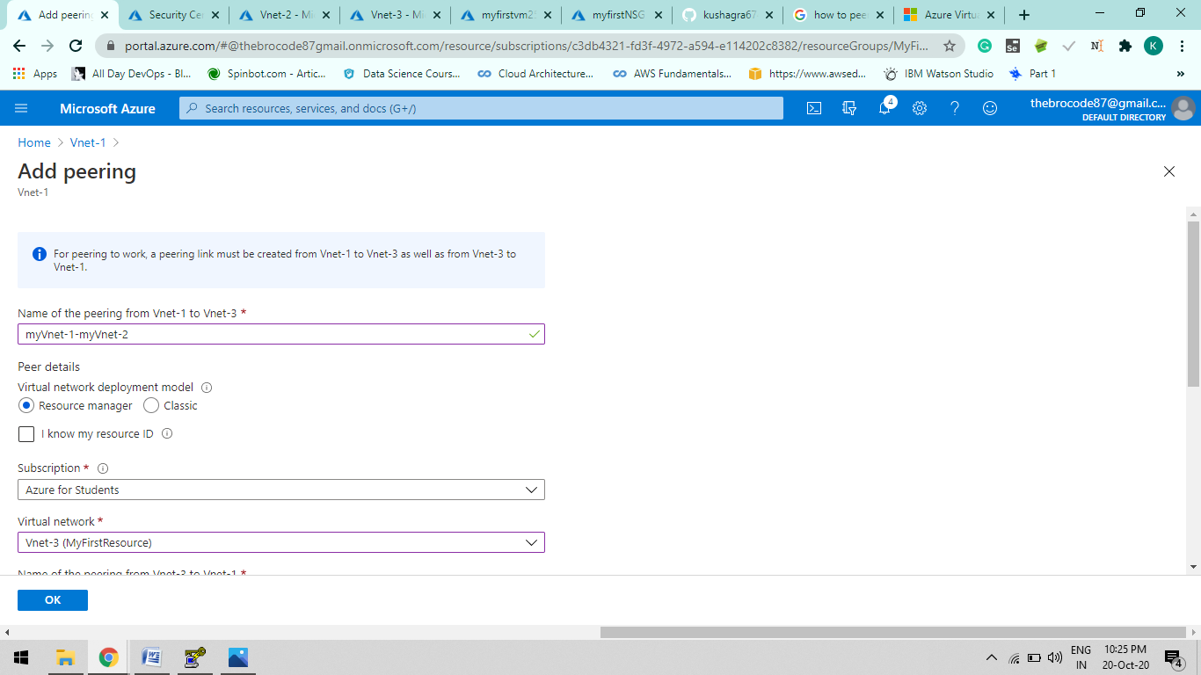

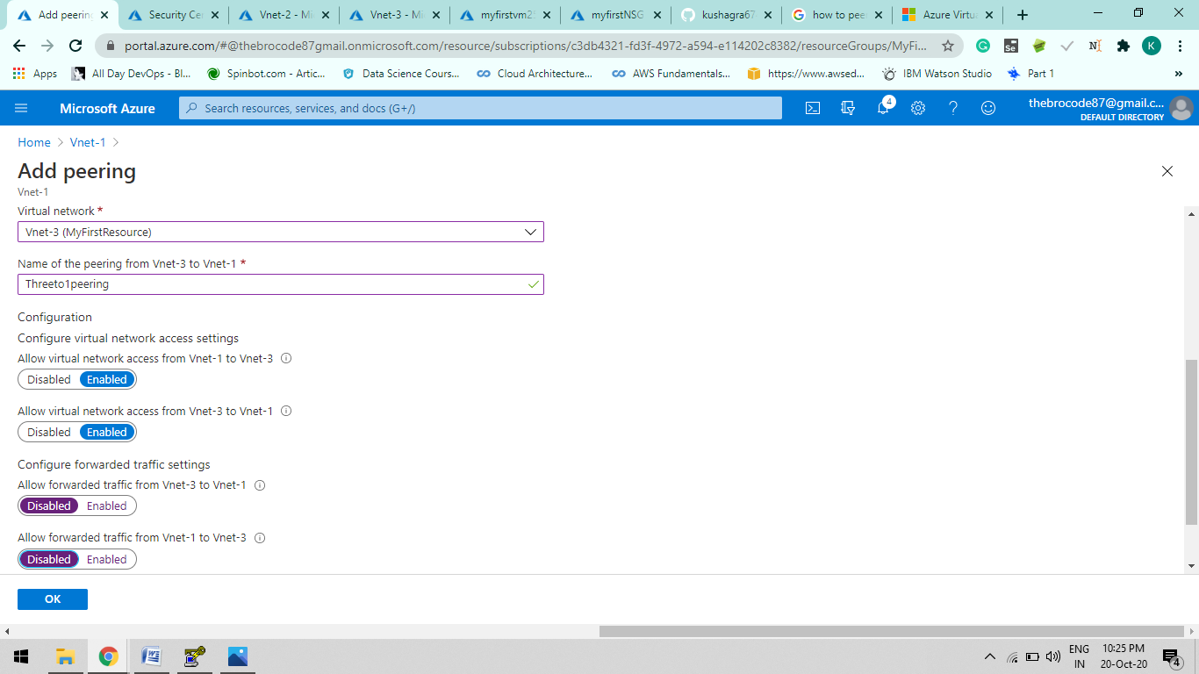

C. 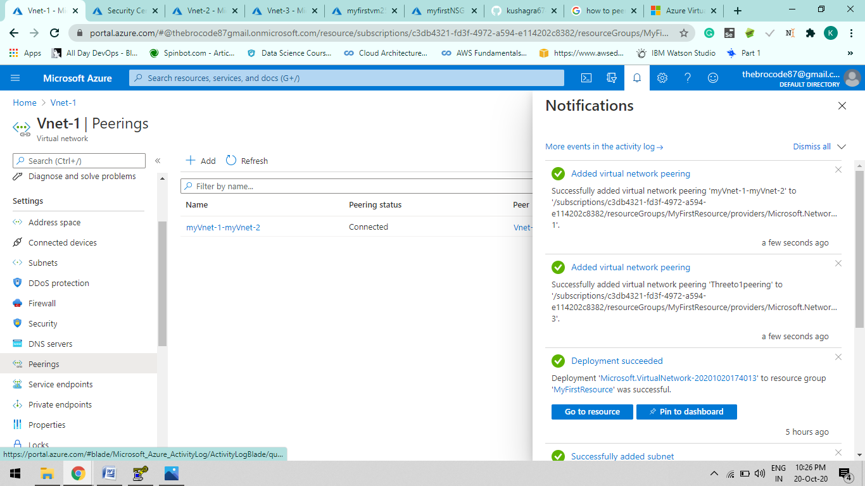

D.

Now go to virtual machine of having Vnet-1 Configuration. And click to connect at left side menu

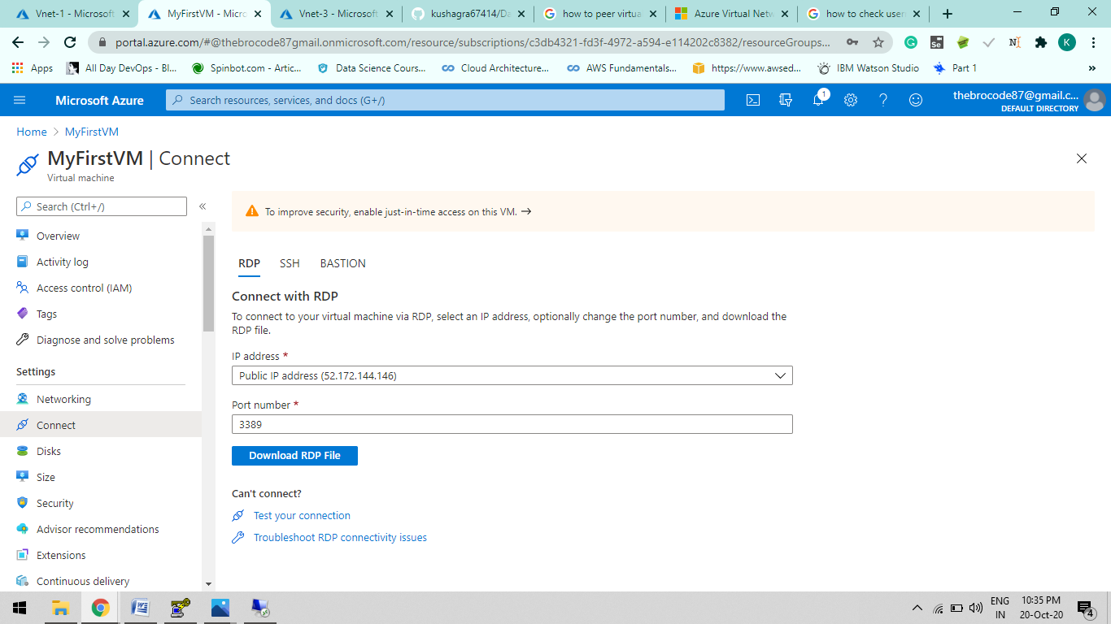

E. RDP – Connection Configuration File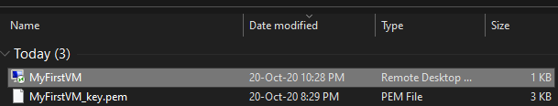

F. Click at MyFirstVM. A promt dialogue box will appear add your Credentials of your Virtual Machine.

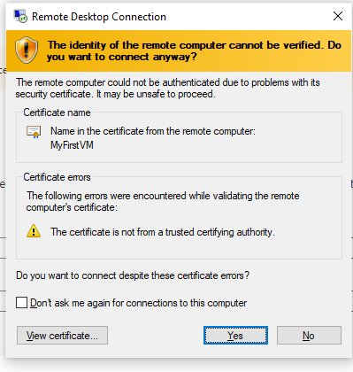

1. You will be direct to your new Windows Virtual machine

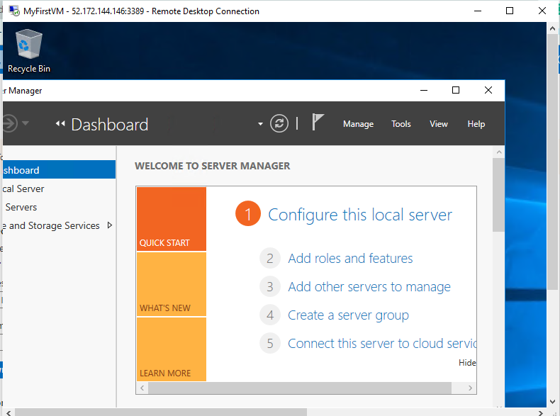

Step-6: Create a data disk and attach to VM-1 & Log on to VM and initialize the disk .

1. Create a disk to a Virtual Machine.

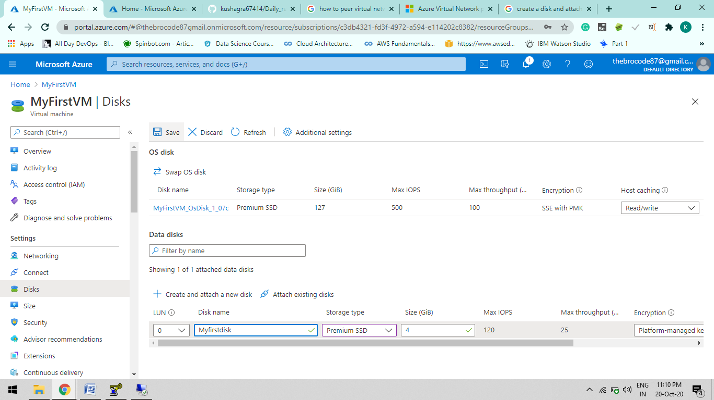

1. After that, Open your hosted Windows Virtual Machine and go to My pc you will see your SDD Add on to you Virtual Machine.

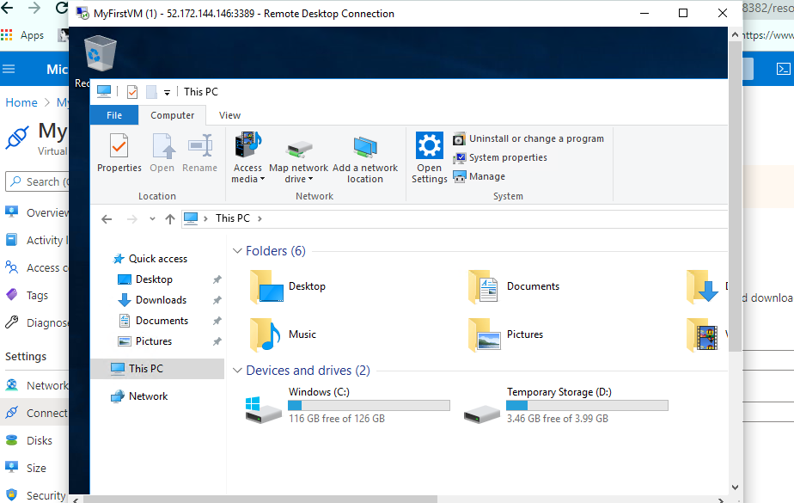

We can Also rename our Drive on VM, Like this

Just right click and rename which implies it is as same as your local machine.

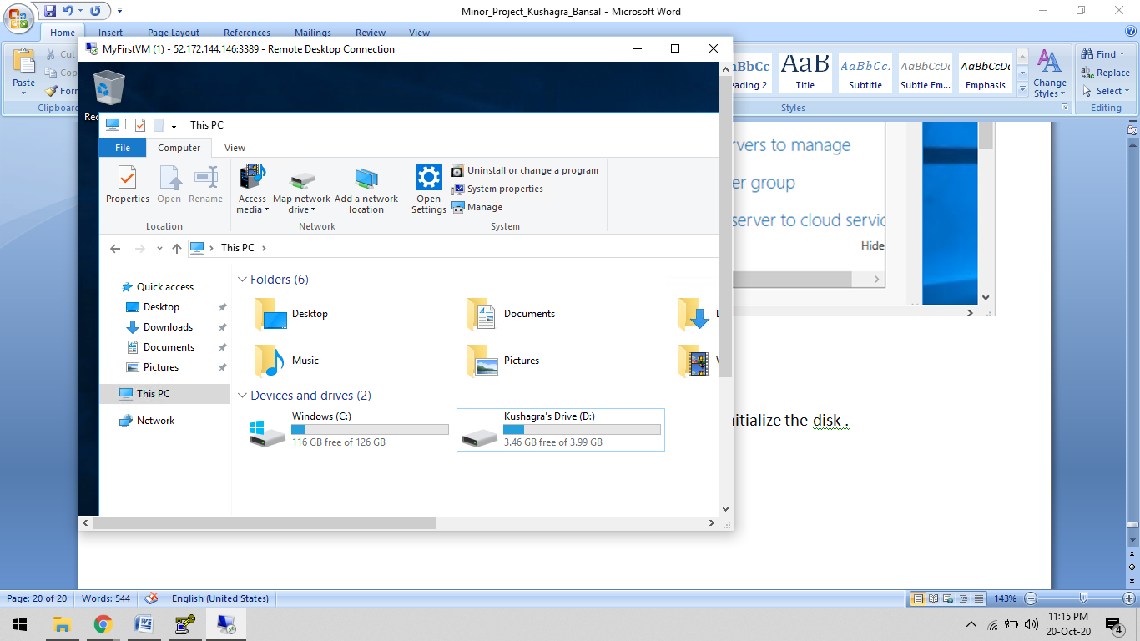

Thank You !!!!!

Kushagra Bansal